MySQL Assignment 2 – Querying Data
1. Data Verification:
SQL Query:
SELECT * FROM Departments;
SELECT * FROM Locations;
SELECT * FROM Employees;
Explanation:
- The SELECT * statement retrieves all records from the specified table.
- This step verifies that all department, location, and employee records have been inserted successfully before executing the SQL queries.
- It ensures that the database is ready for further operations.
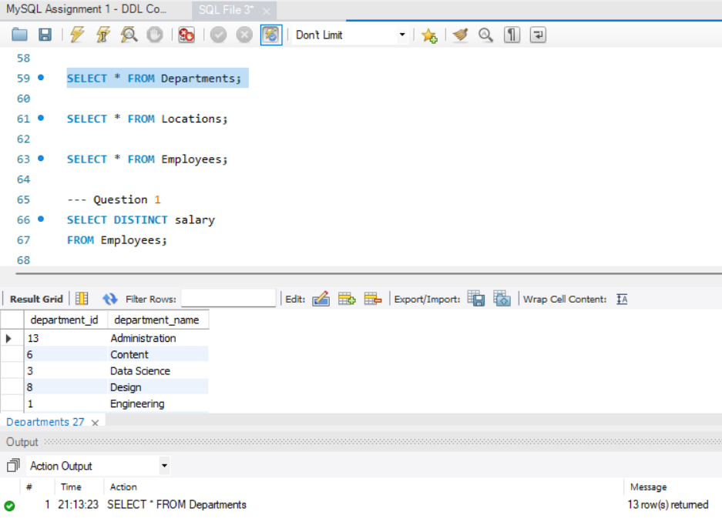
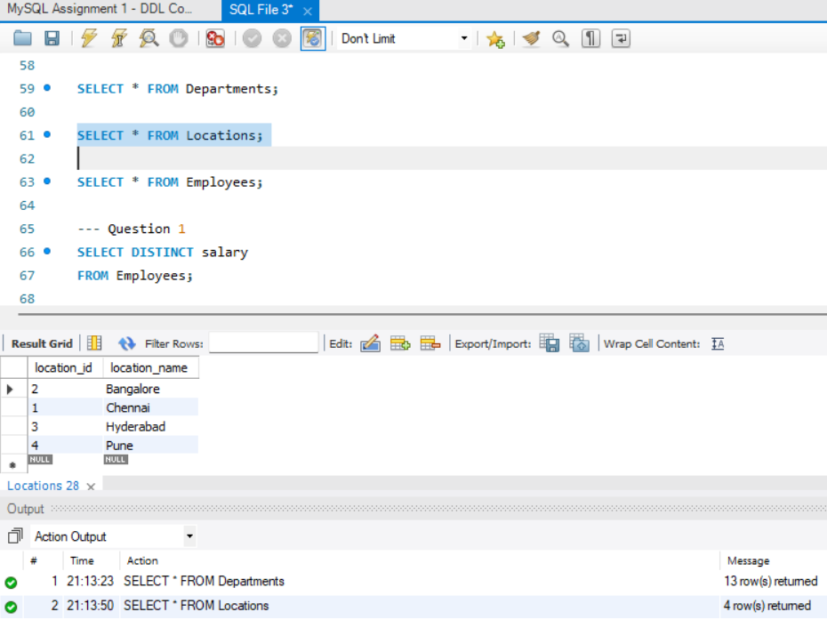
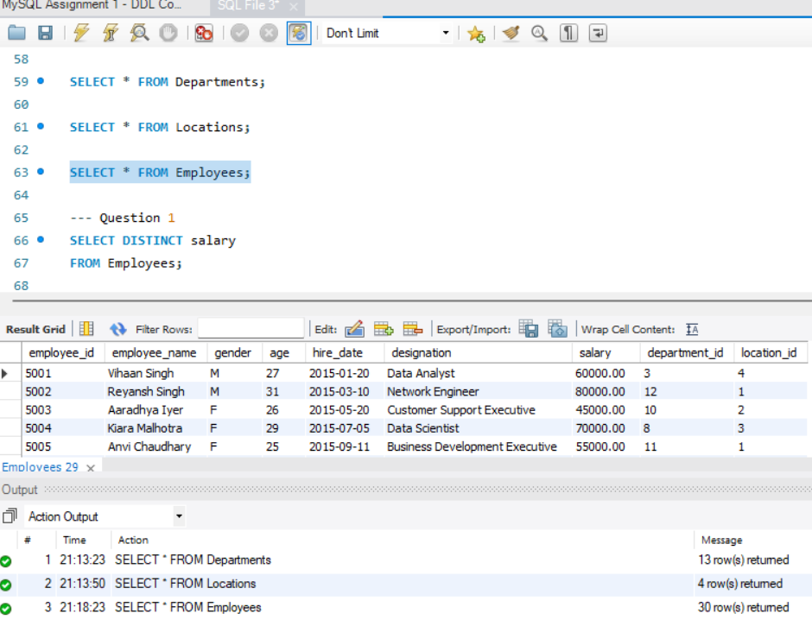

2. DISTINCT Values:
SQL Query:
SELECT DISTINCT salary
FROM Employees;
Explanation:
- The DISTINCT keyword retrieves only unique salary values.
- Duplicate salary values are removed from the output.
- This helps identify all different salary amounts available in the Employees table.
3. Alias (AS):
SQL Query:
SELECT
employee_name,
age AS Employee_Age,
salary AS Employee_Salary
FROM Employees;
Explanation:
- The AS keyword assigns temporary names to the selected columns.
- It improves the readability of the query result.
- The original table structure remains unchanged.
4. WHERE Clause:
SQL Query:
SELECT *
FROM Employees
WHERE salary > 50000
AND hire_date < '2016-01-01';
Explanation:
- The WHERE clause filters records based on specified conditions.
- The AND operator ensures both conditions are satisfied before displaying the records.
SQL Query:
SELECT *
FROM Employees
WHERE designation IS NULL;

UPDATE Employees
SET designation='Data Scientist'
WHERE employee_id=5004;

SELECT *
FROM Employees
WHERE employee_id=5004;
Explanation:
- The first query identifies employees with missing designation values.
- The UPDATE statement modifies the missing designation.
- The final query verifies that the record has been updated successfully.
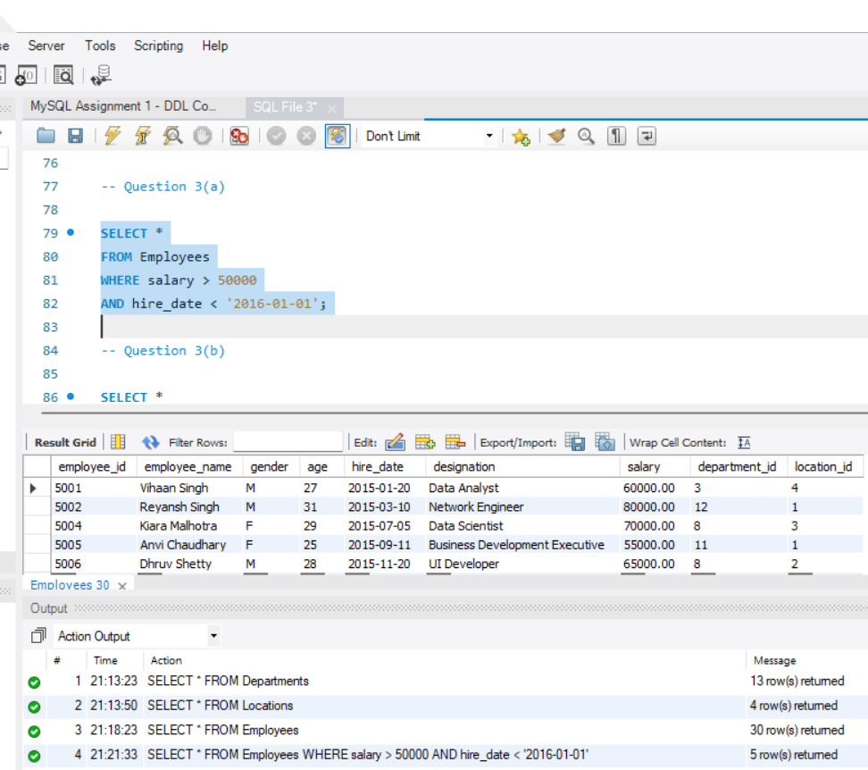
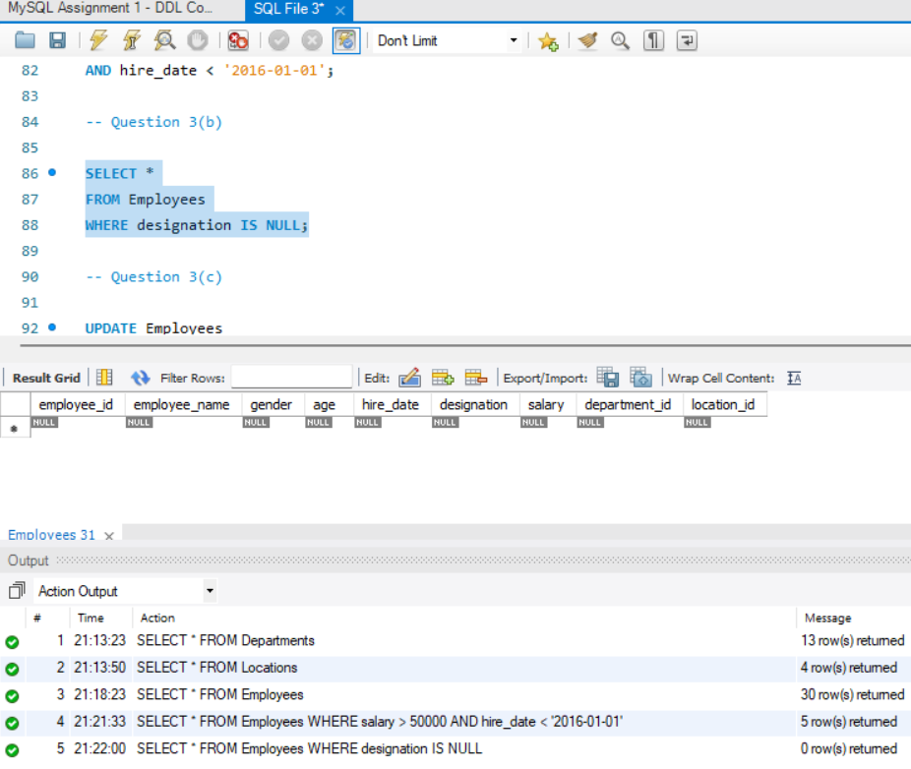
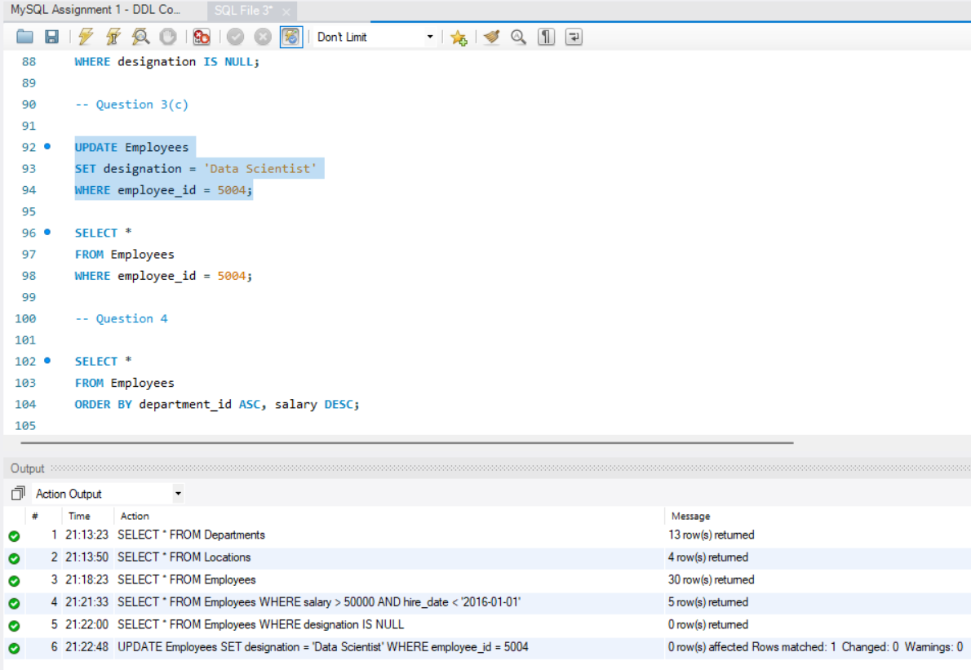
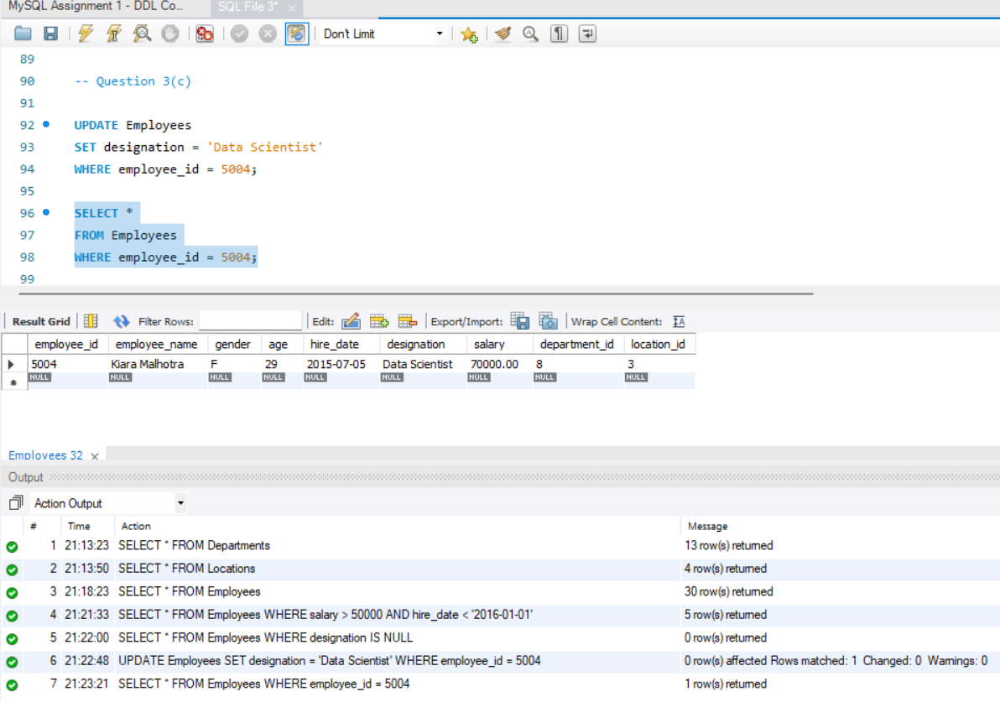
5. ORDER BY Clause:
SQL Query:
SELECT *
FROM Employees
ORDER BY department_id ASC, salary DESC;
Explanation:
- The ORDER BY clause sorts records.
- Employees are arranged in ascending order of department ID.
- Within each department, employees are sorted by salary in descending order.
6. LIMIT Clause:
SQL Query:
SELECT *
FROM Employees
WHERE YEAR(hire_date)=2018
LIMIT 5;
Explanation:
- The YEAR() function extracts the year from the hire date.
- LIMIT 5 displays only the first five matching records.

7. Aggregate Functions:
SQL Query:
SELECT SUM(salary) AS Total_Finance_Salary
FROM Employees
WHERE department_id=7;

SELECT MIN(age) AS Minimum_Age
FROM Employees;
Explanation:
- SUM() calculates the total salary of employees in the Finance department.
- MIN() identifies the youngest employee's age.
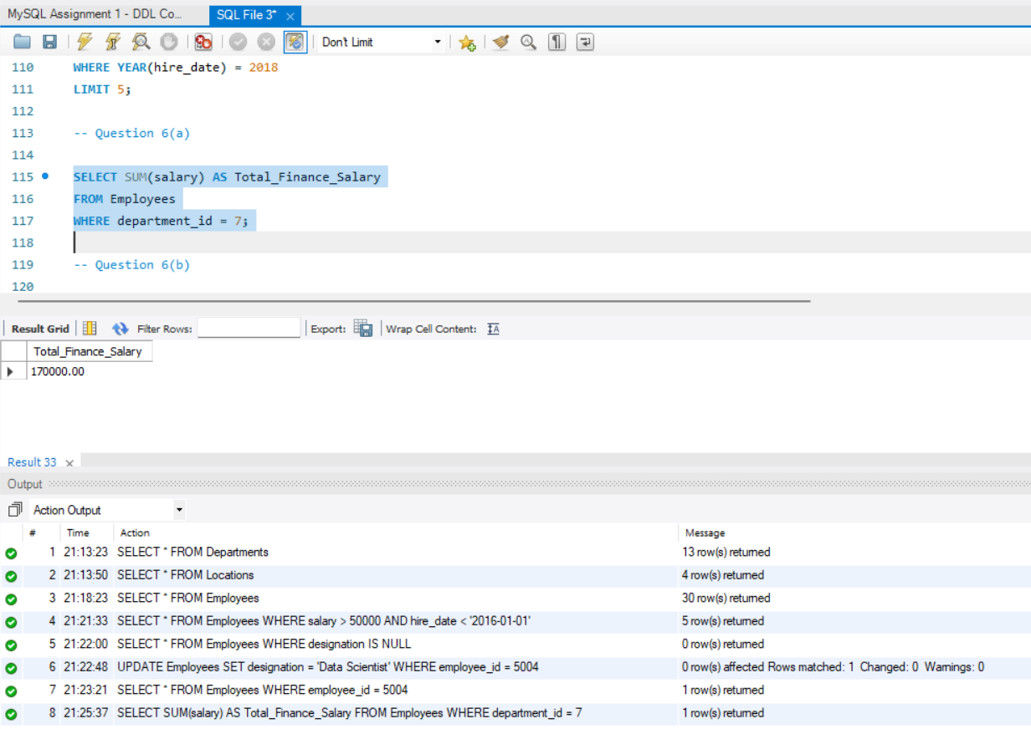
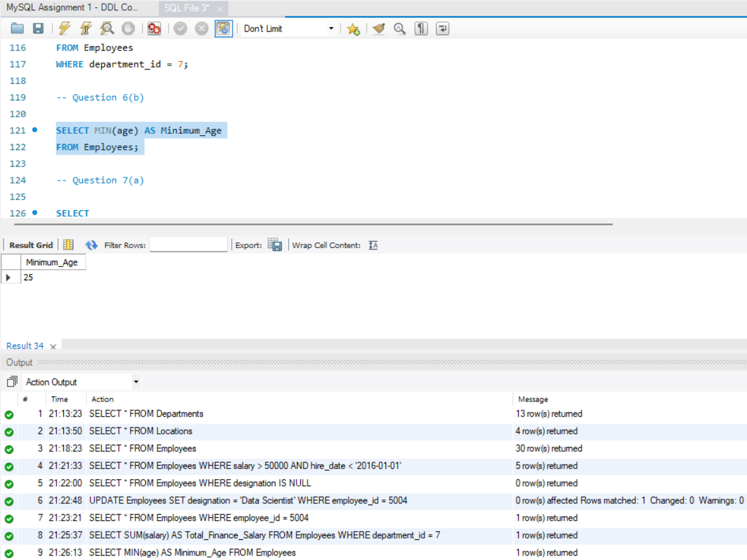
8. GROUP BY Clause:
SQL Query:
SELECT
l.location_name,
MAX(e.salary) AS Maximum_Salary
FROM Employees e
INNER JOIN Locations l
ON e.location_id=l.location_id
GROUP BY l.location_name;

SELECT
designation,
AVG(salary) AS Average_Salary
FROM Employees
WHERE designation LIKE '%Analyst%'
GROUP BY designation;
Explanation:
- GROUP BY groups similar records together.
- MAX() retrieves the highest salary for each location.
- AVG() calculates the average salary for each analyst designation.
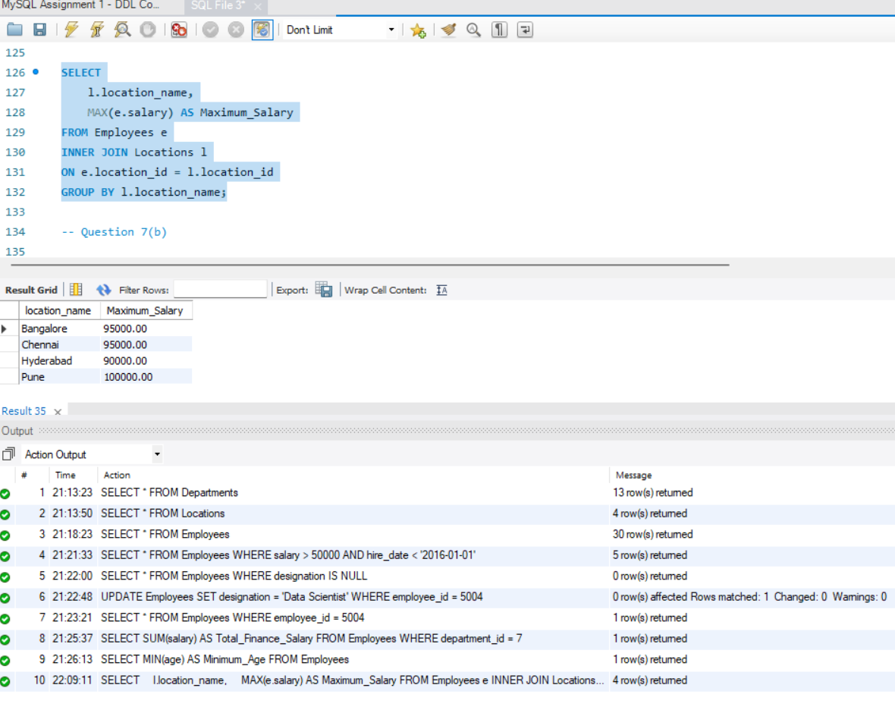

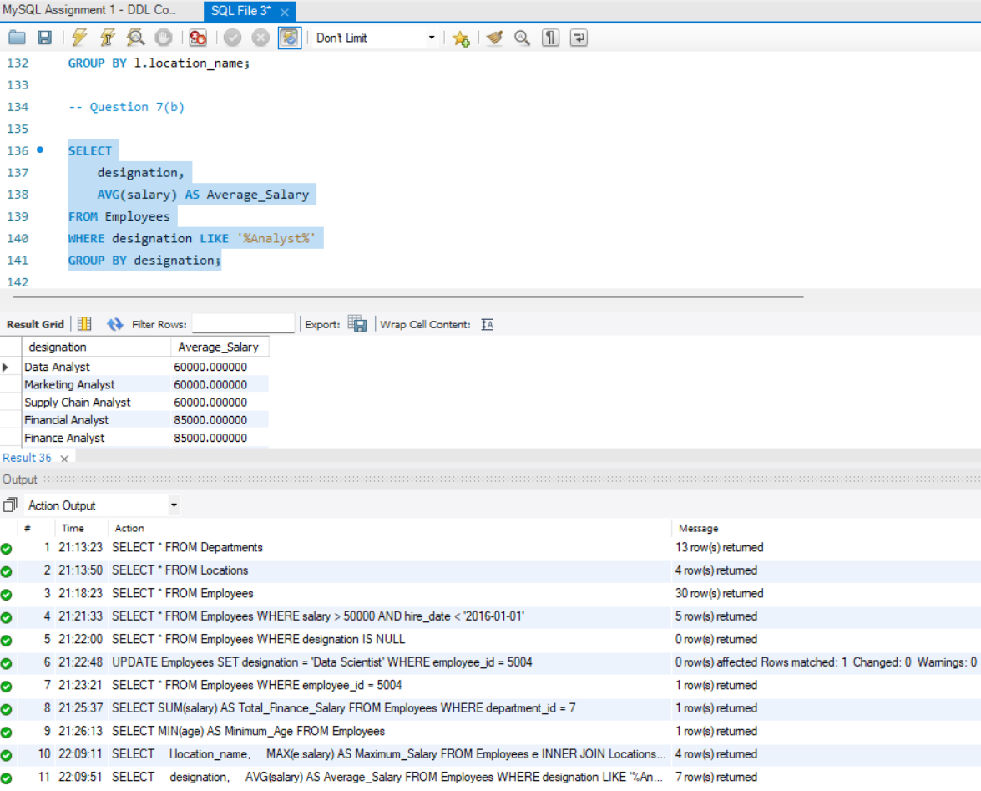
9. HAVING Clause:
SQL Query:
SELECT
department_id,
COUNT(employee_id) AS Employee_Count
FROM Employees
GROUP BY department_id
HAVING COUNT(employee_id)<3;

SELECT
l.location_name,
AVG(e.age) AS Average_Age
FROM Employees e
INNER JOIN Locations l
ON e.location_id=l.location_id
WHERE gender='F'
GROUP BY l.location_name
HAVING AVG(age)<30;

Explanation:
- The HAVING clause filters grouped records after applying aggregate functions.
- It displays departments with fewer than three employees.
- It also displays locations where the average age of female employees is below 30 years.
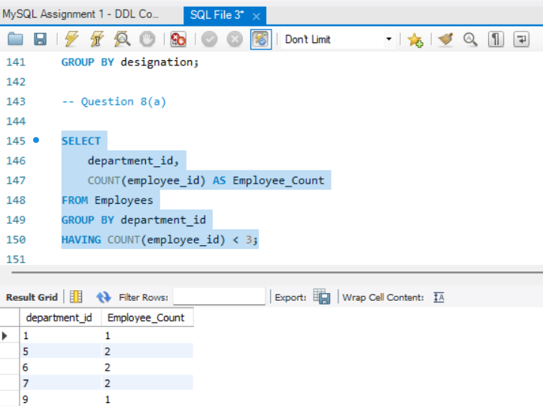
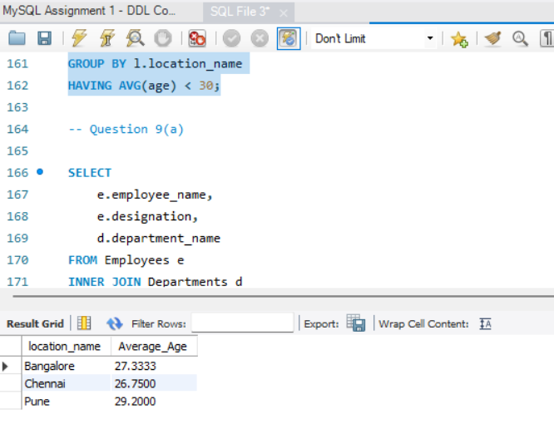

10. JOINS:
SQL Queries:
INNER JOIN:
SELECT
e.employee_name,
e.designation,
d.department_name
FROM Employees e
INNER JOIN Departments d
ON e.department_id = d.department_id;
LEFT JOIN:
SELECT
d.department_name,
COUNT(e.employee_id) AS Total_Employees
FROM Departments d
LEFT JOIN Employees e
ON d.department_id = e.department_id
GROUP BY d.department_id, d.department_name;
RIGHT JOIN:
SELECT
l.location_name,
e.employee_name
FROM Employees e
RIGHT JOIN Locations l
ON e.location_id = l.location_id;
Explanation:
- INNER JOIN retrieves only matching records from both tables.
- LEFT JOIN returns all records from the Departments table along with matching employee records.
- RIGHT JOIN returns all records from the Locations table, including locations without employees.
